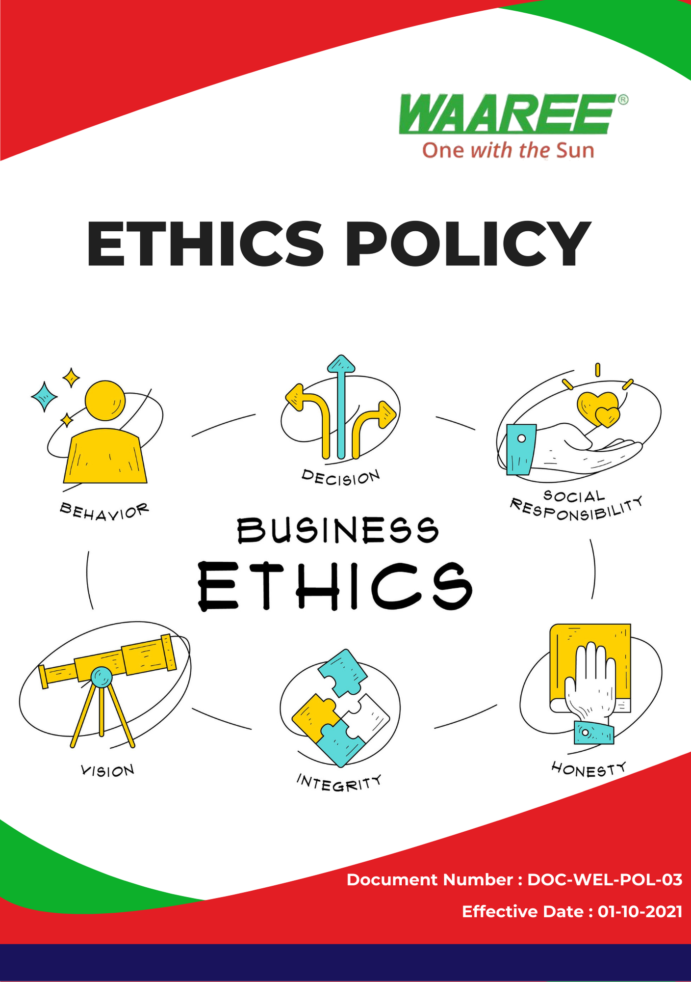

Index

❖ Introduction: 3
❖ Scope: 3
❖ Ethics Commitment: 3
❖ Quantitative Targets: 4
❖ Action Framework: 5
❖ Roles and Responsibilities: 6
❖ Disciplinary Measures: 6
❖ Monitoring and Reporting: 7
❖ Communication and Transparency: 7
❖ Continuous Improvement: 7
❖ SDGs (Sustainable Development Goals) Covered in the Ethics Policy 8
❖ Review: 8
❖ Employee Acknowledgment: Ethics Policy 9

Introduction:
At Waaree Energies Ltd.(Group), we are committed to conducting business with the highest standards of ethics, transparency, and integrity. Our Ethics Policy reflects our dedication to upholding responsible business practices in all aspects of our operations. This policy provides a framework to guide decision-making, prevent unethical behavior, and promote an ethical culture within our organization. We expect all employees, contractors, and business partners to adhere to the principles outlined in this policy, ensuring that Waaree operates with integrity and in compliance with all applicable laws.

Scope:
This policy applies to all Waaree Energies Ltd. (Group) employees, contractors, suppliers, partners, and stakeholders globally. It covers all of our operational sites, which are mentioned below, including relationships with clients, suppliers, regulators, and the broader community.

Sr. No. | Manufacturing Plant | Address
1 | Gujarat – Surat | Plot No. 231 – 236, Surat Special Economic Zone, Diamond Park Sachin, Surat 394230, Gujarat
2 | Gujarat – Tumb | Survey No. 38/1, Tumb Village, Tumb, Umbergaon, Valsad, Gujarat – 396150
3 | Gujarat – Chikhli | WAAREE SHREE GODIJI FACTORY, New Survey no. 1928 Village Degam, Taluka, Chikhli, Gujarat 396530
4 | Gujarat –Nandigram | CBIPL NANDIGRAM Unnamed Road, Nandigam, Gujarat 396105

Ethics Commitment:
Waaree Energies Ltd. is dedicated to ethical business practices and is committed to upholding the following principles.
- Corruption: Waaree has a zero-tolerance policy toward corruption in all its forms, including bribery, extortion, and illicit payments. We require that all employees and partners act with integrity and avoid engaging in any activity that could be perceived as corrupt. We have implemented robust internal controls to detect and prevent corrupt practices across all levels of the organization.
- Conflict of Interest: All employees are required to avoid situations where personal interests could conflict, or appear to conflict, with the interests of Waaree. Conflicts of interest must be disclosed immediately, and Waaree’s leadership will ensure that appropriate steps are taken to resolve such conflicts ethically and transparently.
- Fraud Prevention: Waaree takes active measures to prevent, detect, and address fraud. We have implemented a fraud management system that includes internal audits, reporting mechanisms, and strict consequences for fraudulent activities. All employees are required to report any suspicious activities related to fraud to the relevant authorities within the company.
- Money Laundering: Waaree is committed to preventing money laundering and complying with all applicable anti-money laundering (AML) regulations. We have established due diligence procedures for our financial transactions, customer verification processes, and regular monitoring to ensure compliance. Employees and partners are required to report any suspicious financial activities.
- Anti-Competitive Practices: Waaree ensures that it operates in a manner that promotes fair competition and complies with all applicable antitrust laws. We do not engage in anti-competitive practices such as price-fixing, collusion, or bid-rigging, and we ensure that our operations maintain the integrity of the competitive market.
- Information Security: Waaree recognizes the critical importance of information security and data protection. We have comprehensive policies in place to protect sensitive and confidential information from unauthorized access, use, or disclosure. Our information security management system includes regular risk assessments, employee training, and secure data handling protocols to safeguard company, employee, and customer information.

Quantitative Targets:
- Sets 2022 as the baseline for tracking our ethical compliance and performance.

- Corruption:
- Conduct annual anti-corruption training for 100% of employees by 2025.
- Achieve zero confirmed incidents of corruption or bribery across all operations by 2025.
- Conflict of Interest:
- Implement a conflict-of-interest declaration system for 100% of employees by 2025.
- Resolve 100% of disclosed conflicts of interest within 30 days of reporting.
- Fraud Prevention:
- Increase internal fraud detection rates by 10% by 2025 through enhanced audit systems and reporting channels.
- Conduct biannual fraud prevention workshops for all employees.
- Money Laundering:
- Ensure 100% compliance with anti-money laundering regulations by 2025 through regular training and monitoring.
- Conduct annual AML audits across all financial transactions by 2025.
- Anti-Competitive Practices:
- Achieve full compliance with all global and local antitrust laws by 2025.
- Conduct annual audits to ensure no anti-competitive practices are occurring within Waaree's operations or partnerships.

- Information Security:
- Conduct quarterly information security risk assessments across all departments by 2025.
- Reduce information security incidents by 20% by 2025 through employee training and technology upgrades.

Action Framework:
- Corruption Prevention: Waaree regularly conducts internal and external audits to identify any potential corruption risks. All employees are trained to recognize and report any suspicious behavior related to bribery or unethical payments.
- Conflict of Interest Disclosure: Employees are required to declare any potential conflicts of interest using a formal disclosure system. Waaree’s leadership reviews these disclosures and ensures they are addressed appropriately and ethically.
- Fraud Management System: Waaree has implemented a comprehensive fraud detection and reporting system, supported by internal audits and regular fraud awareness workshops. All employees are trained to identify fraudulent activities and report them through a confidential reporting channel.
- AML Compliance: Waaree implements due diligence processes, including customer verification, transaction monitoring, and annual AML audits, to ensure compliance with anti-money laundering regulations.
- Fair Competition Monitoring: Waaree conducts regular antitrust audits to ensure compliance with anti-competitive regulations and promotes ethical business practices across all partnerships.
- Information Security Measures: Waaree employs a robust information security management system that includes regular cybersecurity risk assessments, secure handling of data, employee training, and encryption technologies to protect sensitive information.

Roles and Responsibilities:
- Ethics and Compliance Officer: Oversees the implementation of Waaree’s Ethics Policy, monitors compliance with anti-corruption, anti-fraud, and anti-money laundering regulations, and addresses potential conflicts of interest.
- Internal Audit Team: Conducts audits related to fraud, anti-competitive practices, and financial transparency to ensure the effectiveness of internal controls.
- Information Security Manager: Ensures the protection of sensitive data and leads initiatives to prevent information security breaches.
- Employees: All employees are responsible for adhering to ethical standards, reporting violations, and participating in regular ethics and compliance training.

Disciplinary Measures:
Waaree Energies Ltd. enforces strict disciplinary measures for violations of the Ethics Policy. We ensure that all employees, contractors, and partners understand the consequences of unethical behavior. The severity of disciplinary actions is proportional to the nature and impact of the violation.
The disciplinary measures that may be taken for policy violations include but are not limited to:
- Verbal or Written Warning:
- Issued for minor violations or first-time offenses. Employees receive a formal warning that outlines the violation and corrective actions to avoid future incidents.
- Suspension:
- Employees may be temporarily suspended from their duties for repeated violations or more severe offenses. This may also apply to employees involved in incidents of negligence, such as failing to report unethical behavior.
- Termination of Employment or Contracts:
- In cases of severe breaches, such as fraud, bribery, corruption, or conflicts of interest that compromise Waaree’s integrity, immediate termination of employment or contracts may be enforced. This includes actions that directly violate legal regulations or damage the company’s reputation.
- Legal Action:
- In cases where violations of the Ethics Policy constitute a breach of the law (e.g., fraud, money laundering, corruption), Waaree will not hesitate to take legal action. This includes referring the matter to law enforcement authorities and pursuing criminal charges or civil litigation.
- Restitution and Financial Penalties:
- In cases of fraud or financial misconduct, Waaree may seek restitution from employees, requiring the individual to repay any financial losses incurred by the company. In addition, financial penalties may be imposed on contractors or partners who breach ethical standards.
- Training and Rehabilitation Programs:
- For certain violations, employees may be required to undergo ethics training or participate in rehabilitation programs to ensure that they understand the company’s ethical standards and avoid future violations. This is often used in conjunction with lesser disciplinary actions such as warnings or suspensions.
Waaree’s disciplinary measures aim not only to correct unethical behavior but also to deter future violations, thereby fostering a culture of accountability and integrity.

Monitoring and Reporting:
- Ethics Hotline: Waaree has established a confidential ethics hotline that allows employees to report concerns or violations related to corruption, fraud, or conflicts of interest without fear of retaliation.
- Internal and External Audits: Regular audits will be conducted to ensure compliance with anti-corruption, AML, antitrust, and fraud prevention regulations.
- Incident Reporting: All incidents of corruption, fraud, or breaches of ethical standards are investigated thoroughly, and corrective actions are taken immediately.

Communication and Transparency:
- Waaree’s Ethics Policy is publicly available on the company website and is regularly communicated to all employees and stakeholders through internal newsletters and meetings.
- Employees are encouraged to engage in open dialogue about ethical concerns and can report issues anonymously through a dedicated reporting channel.

Continuous Improvement:
Waaree Energies Ltd. remains dedicated to improving its ethical practices and continuously reviewing its policies to meet evolving legal and ethical standards. We regularly assess the effectiveness of our Ethics Policy and take action to address new risks and challenges. Our commitment to ethics is fundamental to our corporate values and integral to maintaining trust with our employees, partners, and the wider community.

SDGs (Sustainable Development Goals) Covered in the Ethics Policy




Review:
The Ethics Policy will be reviewed annually by the Ethics and Compliance Officer and the Internal Audit Team to ensure its effectiveness and relevance. The review will consider changes in regulations, stakeholder feedback, and company goals. Any updates will be communicated to all employees and stakeholders. Progress toward the policy’s targets will also be evaluated, with adjustments made as necessary.

Approved By:

Designation:

Last Review Date: 01/04/2024 Next Review Date: 01/04/2025

Employee Acknowledgment: Ethics Policy
I, acknowledge that I have received, read, and understood the Ethics Policy of Waaree Energies Ltd.(Group). I am aware of the company’s ethical principles, including its commitment to preventing corruption, fraud, conflicts of interest, and ensuring compliance with anti-money laundering and antitrust regulations.

I understand my role in upholding these ethical standards and agree to adhere to them in all business dealings. I commit to reporting any potential violations of this policy through the appropriate reporting channels. I acknowledge that adherence to this policy is a condition of my continued employment or partnership with Waaree Energies Ltd.(Group).

Employee Name:

Employee Signature:

Date:

